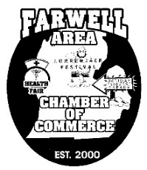
Farwell Area Chamber of Commerce
221 W. Main St., P.O. Box 771 Farwell MI 48622 (989)588-0580
www.farwellareachamber.com facc@farwellareachamber.com

16th Annual Paula Pirnstill Memorial Health & Safety Fair April 18, 2020
Business Information
Company Name __________________________________________________
Address: __________________________________________________
Phone __________________________________________________
Fax __________________________________________________
Website __________________________________________________
Location is Farwell Area High School Gymnasium Adult Health Fair.
The Kids Health Fair will be held in the old High School Gymnasium.
Please make sure to have enough representatives to staff your table(s).
Please bring your OWN tables.
Remember in order to sell your Health Products you must provide Proof of your
Business Sales License before attending the Health Fair on April 18, 2020.

Personal Information
First Name __________________________________________________
Last Name __________________________________________________

Email Address __________________________________________________
What is the best way to reach you? ________________________________
Will you be donating blood at the Health Fair? __________________________
If answering yes, would you like before, during or after the Health Fair?
Each year the Annual Paula Pirnstill Health & Safety Fair is brought about by the donations of local businesses and individuals. We consider your TABLE fee of $10.00 as a donation that helps to support the Fair each year. Please remit the $10.00 fee to: Farwell Area Chamber of Commerce, PO Box 771, Farwell, MI 48622.

